Student Researcher Assigned ID (e.g. A-#1, F-#5): …………………
Consent form Uplifting experiences related to dealing with COVID-19 times
Subject: Permission to participate in Uplifting experiences related to dealing with COVID-19 times in the context of the research surrounding multi-modal systems created for the course designing interactive experiences from the University of Twente, with sessions in May and June 2020.
If you agree that you participate, you can check the first box below indicating that you give your consent, fill in your other details and sign the form. Apart from that, and optionally, you can indicate whether you agree that you can also be on photos or videos used to give an overview of the research and installations, which is used following the faculty’s ethical guidelines only for “didactic purposes (e.g. education, congress presentations, scientific documentary, and the like)” , including future “second” parties that want to function as a stakeholder in this course.
I declare that I
- am fully informed about the research the purpose of the research and the methods have been explained to me, and I have had the space to ask questions.
- give permission for the collection of research materials in the form of questioning & answering, direct observations and those made through audio or other teleconference systems in sessions related to Uplifting experiences related to dealing with COVID-19 times in May/June 2020.
- my questions have been answered to my satisfaction.
- agree out of my own free will to participate in this research.
- understand that I can end my participation at any time, without giving any reason, without any consequences (including later in the school year). This can be done up to 24 hours after participating, please indicate the time of participation.
- authorize the use and know of risks of the video calling program, software to be installed, or (preparatory) actions needed for the interaction.
- know that if my research results are to be used in scientific publications in any manner, then they will be made anonymous to the extent possible (e.g. photos of blurred faces and clothing, not linked to remarks made, not using names in videos etc.).
- will indicate, besides filling in the check box below or not, in a clear manner to the involved student researchers whether (video) recordings are allowed or not.
I also give permission to take photos, snapshots, videos, or screen recordings of my participation. In order to provide a good overview for the research that is being done. I hereby give permission to have these photos or videos made and used for the didactic purposes.
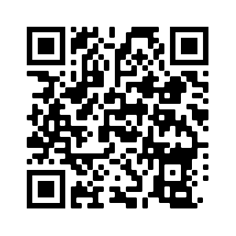
Name Participant ………………………………………………………………………………………
Date ……………………………………………………………………………………………
Signature:
……………………………………………………………………………………………………….
Please upload to:
https://surfdrive.surf.nl/files/index.php/s/viwiSuzqIUSvDHE

